An Inclusive Philosophy and the Education System:
1.1 Placemat Activity
Timeframe: 20 to 30 minutes
Materials: Chart Paper
Markers
This activity is designed to allow for each individual’s thinking, perspective and voice to be heard and recognized.
- Break into small groups.
- On a piece of chart paper, one member of each group will draw a central oval or box and divide the surrounding area into the number of sections which corresponds with the number of members in the small group. The sample shown is for a group with 4 members.
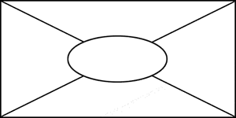
- Each participant chooses an outer section in which to record his or her own ideas about inclusive education.
- Participants share ideas with group members.
- A nominated scribe uses the oval in the middle of the paper to note down the points common to all participants.
- Each group reports the common points to the whole group.

